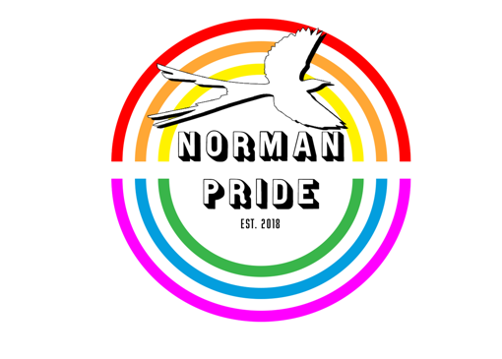
Norman Pride Royalty Pageant
Judges Score Sheet
Creative Pride Costume

Suitability of Costume: 0 – 10 Points:
*Does the costume fit with the overall theme chosen by the entertainer?

Hairstyle: 0 – 10 Points:
*How well does the contestants hair match with the rest of their presentation?

Presentation: 0 – 10 Points:
*Modeling Techniques, Poise, Smile, etc.

General Appearance: 0 – 10 Points:
*Make-Up, Shoes, Costume Condition, Accessories

Notes:

Total Points:
Points Possible = 40

Norman Pride Royalty Pageant
Judges Score Sheet
Talent

Showmanship and props: 0 – 10 Points:
*Are props in good condition?

Choreograph: 0 – 10 Points:
*Physical Coordination and Stage Presence

Quality : 0 – 10 Points:
*Lip-sync, Live Vocal, and or Other Entertainment

Value: 0 – 10 Points:
*Presentation as Entertainment

Notes:

Total Points:
Points Possible = 40

Norman Pride Royalty Pageant
Judges Score Sheet
On Stage Question

Stage Presence: 0 – 10 Points:
*Personality, Poise, Mic. Handling

Ability to Communicate: 0 – 10 Points:

Answer Content: 0 – 10 Points:

Notes:

Total Points:
Points Possible = 30

Norman Pride Royalty Pageant
Judges Score Sheet
Totals

Contestant Name:[ fill in contestant name before printing]

Creative Pride Costume: 0 – 40 Points:

Talent: 0 – 40 Points:

On Stage Question: 0 – 30 Points:

Notes:

Total Points:
Points Possible = 110

Norman Pride Royalty Pageant
Judges Score Sheet
On Stage Question Tie Breaker

Ability to Communicate: 0 – 10 Points:

Answer Content: 0 – 10 Points:

Notes:

Total Points:
Points Possible = 20

